**PATUAKHALI SCIENCE AND TECHNOLOGY UNIVERSITY**

Course Code: C

IT

-

11

2



**SUBMITTED TO:**

Prof. MD Mahbubur Rahman Sir

**Department of Computer Science And Communication**

**Engineering**

**Faculty of Computer Science And Engineering**

**SUBMITTED BY:**

Name: MD Noushad Bhuiyan

ID: 2102038, Registration No: 10165

Faculty of Computer Science and Engineering

**Date of submission: 5-31-2023**

1. Pattern All in one by function

#include<stdio.h>

int pattern1(int n)

{

for(int i=1;i<=n;i++)

{

for(int j=1;j<=i;j++)

{

printf("* ");

}

printf("\n");

}

}

int pattern2(int n)

{

for(int i=0;i<n;i++)

{

for(int j=n;j>i;j--)

{

printf("* ");

}

printf("\n");

}

}

int pattern3(int n)

{

for(int i=1;i<=n;i++)

{

for(int j=1;j<=n;j++)

{

printf("* ");

}

printf("\n");

}

}

int pattern4(int n)

{

for(int i=1;i<=n;i++)

{

for(int j=1;j<i;j++)

{

printf(" ");

}

for(int j=i;j<=n;j++)

{

printf("* ");

}

printf("\n");

}

}

int pattern5(int n)

{

for(int i=1;i<=n;i++)

{

for(int j=n-1;j<=1;j--)

{

printf(" ");

}

for(int j=i;j<=n;j++)

{

printf("* ");

}

printf("\n");

}

}

int pattern6(int n)

{

for(int i=1;i<=n;i++)

{

for(int j=1;j<=i-1;j++)

{

printf(" ");

}

for(int j=i;j<=n;j++)

{

printf("* ");

}

for(int j=n-1;j<=1;j--)

{

printf(" ");

}

for(int j=i;j<=n;j++)

{

printf("* ");

}

printf("\n");

}

}

int pattern7(int n)

{

for(int i=1;i<=n;i++)

{

for(int j=1;j<=n;j++)

{

if(i==1 || i==n || j==1 || j==n)

printf("* ");

else

printf(" ");

}

printf("\n");

}

}

int pattern8(int n)

{

for(int i=1;i<=n;i++)

{

for(int j=1;j<=n;j++)

{

if(j==i || i==n || j==1)

printf("* ");

else

printf(" ");

}

printf("\n");

}

}

int main()

{

int n;

scanf("%d",&n);

pattern1(n);

printf("\n");

pattern2(n);

printf("\n");

pattern3(n);

printf("\n");

pattern4(n);

printf("\n");

pattern5(n);

printf("\n");

pattern6(n);

printf("\n");

pattern7(n);

printf("\n");

pattern8(n);

}

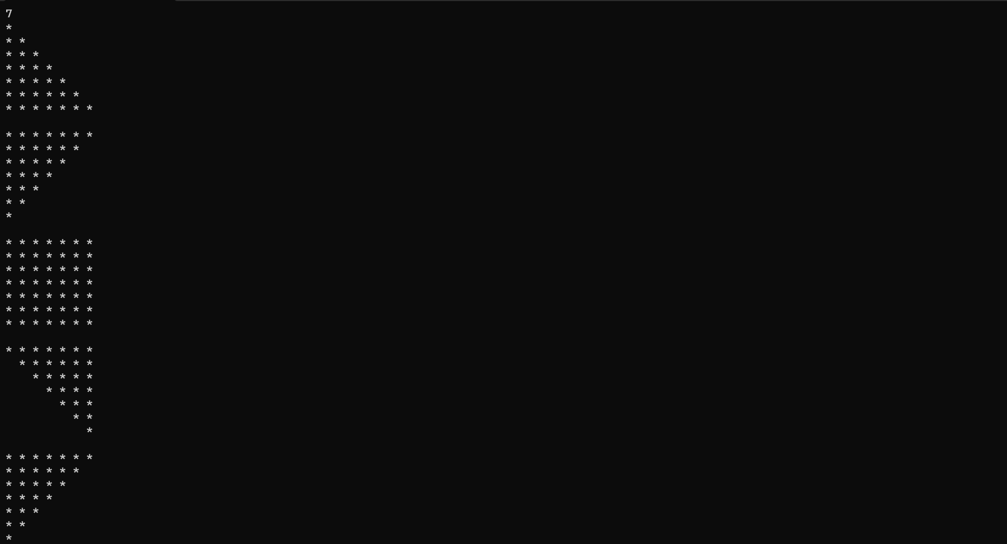

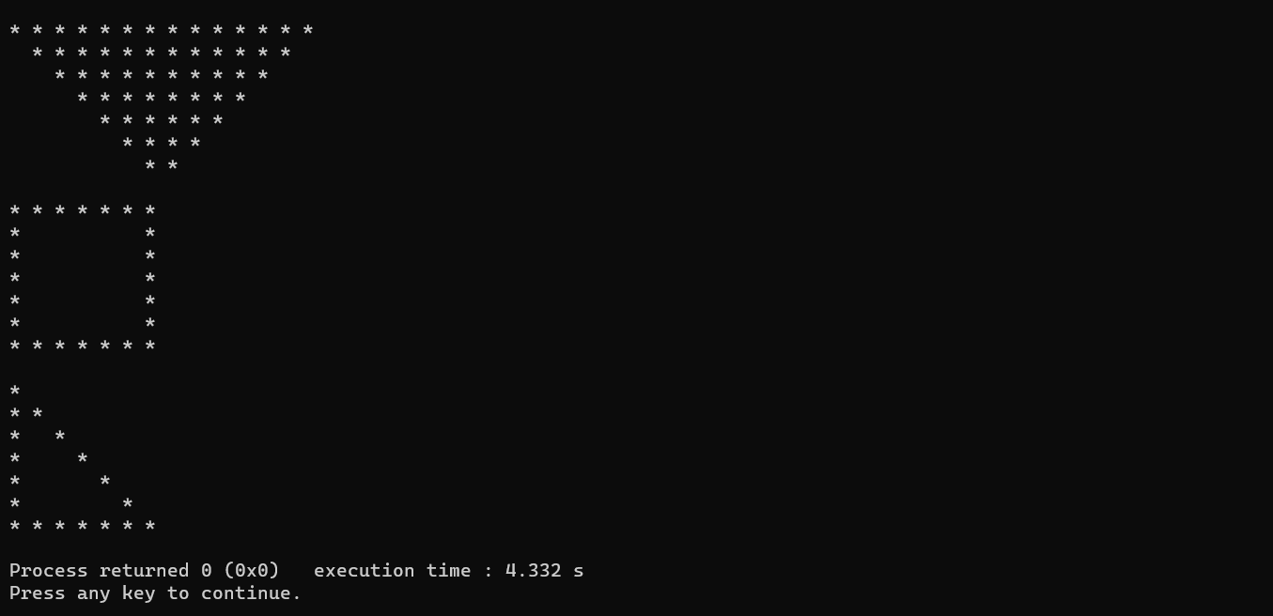

1. Reverse a Number

#include<stdio.h>

int main()

{

int n,sum=0,temp;

printf("Enter an number: ");

scanf("%d",&n);

while(n!=0)

{

temp=n%10;

sum=sum*10+temp;

n=n/10;

}

printf("Reverse of digits: %d",sum);

}

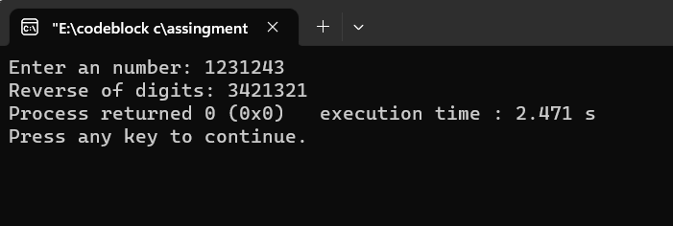

1. Sum of all Digits

#include<stdio.h>

int main()

{

int n,sum=0,r,x;

printf("Enter a number: ");

scanf("%d",&n);

while(n!=0){

r=n%10;

sum=sum+r;

n=n/10;}

printf("Sum of digits are : %d",sum);

}

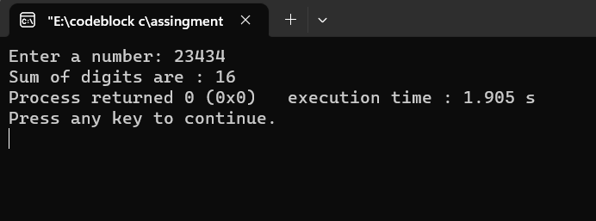

1. Fibonacci Number

#include<stdio.h>

int main()

{ //fibonacci number

int n,i,num1=0,num2=1,fib;

printf("Enter n: ");

scanf("%d",&n);

printf("%d\n",num1);

printf("%d\n",num2);

for(i=0;i<=n-3;i++)

{

fib=num1+num2;

num1=num2;

num2=fib;

printf("%d\n",fib);

}

}

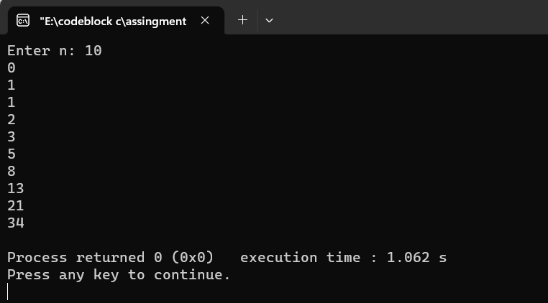

1. Investment Equation

#include<stdio.h>

int main()

{

float p,n,r;

printf("Enter P,n,r:\n");

scanf("%f %f %f",&p,&n,&r);

float x;

x=1+r;

float v;

v=p*pow(x,n);

printf("The value of V is : %0.2f",v);

}

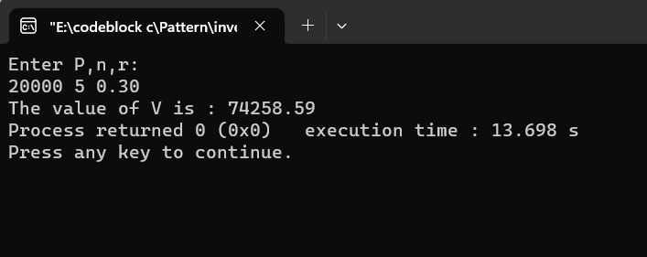

1. E= 1 + ½! + 1/3! + ¼! …….+1/n! math

#include<stdio.h>

int main()

{

float n,sum=0;

printf("Enter n: ");

scanf("%f",&n);

for(int i=1;i<=n;i++)

{

float x=1;

for(int j=1;j<=i;j++)

{

x=x*j;

}

sum=sum+(1/x);

}

printf("%0.2f",sum);

}

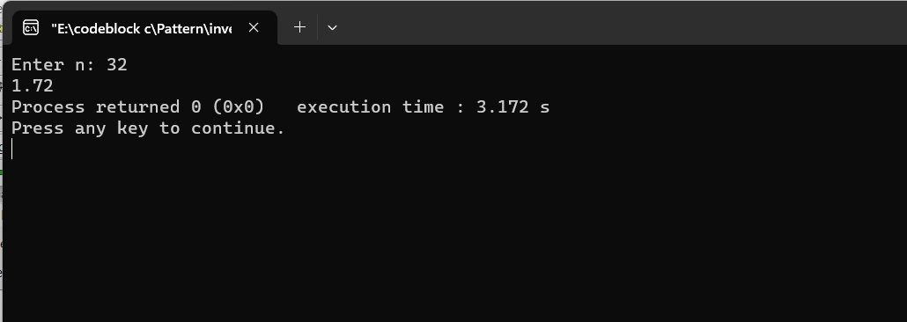

1. Factorial Value

#include<stdio.h>

int main()

{

int n;

printf("Enter n: ");

scanf("%d",&n);

int sum=1;

for(int i=1;i<=n;i++)

sum=sum*i;

printf("The factorial Value is: %d",sum);

}

